1. You are calibrating the reticle on your microscope using the 4x objective lens.
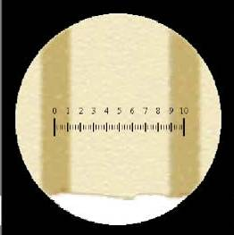

On this microscope, how many reticle units are there per mm?
a. 1
b. 10
c. 20
*d. 50
e. 100

2. You have 4L of a salt water solution that is four times more concentrated than
sea water (4x seawater). For your experiment, you need to make 200 mL of
each of the following concentrations:
2x seawater, 1x seawater, 0.5x seawater, 0.25x seawater.
You will need how many mL of stock solution to make the 2x solution?
a. 12.5
b. 25
c. 50
d. 75
*e. 100

3. If you are using the low power objective on a compound microscope to view a
Paramecium, what is the total magnification of the image?
a. 4x
b. 10x
c. 40x
*d. 100x
e. 400x
4. If you are using the scanning power objective on a standard compound
microscope to view a Paramecium, what is total magnification (TM) of the image?
a. 4x
b. 10x
*c. 40x
d. 100x
e. 400x

5. If you are using this microscope to view a Paramecium, what is total magnification (TM) of the image?
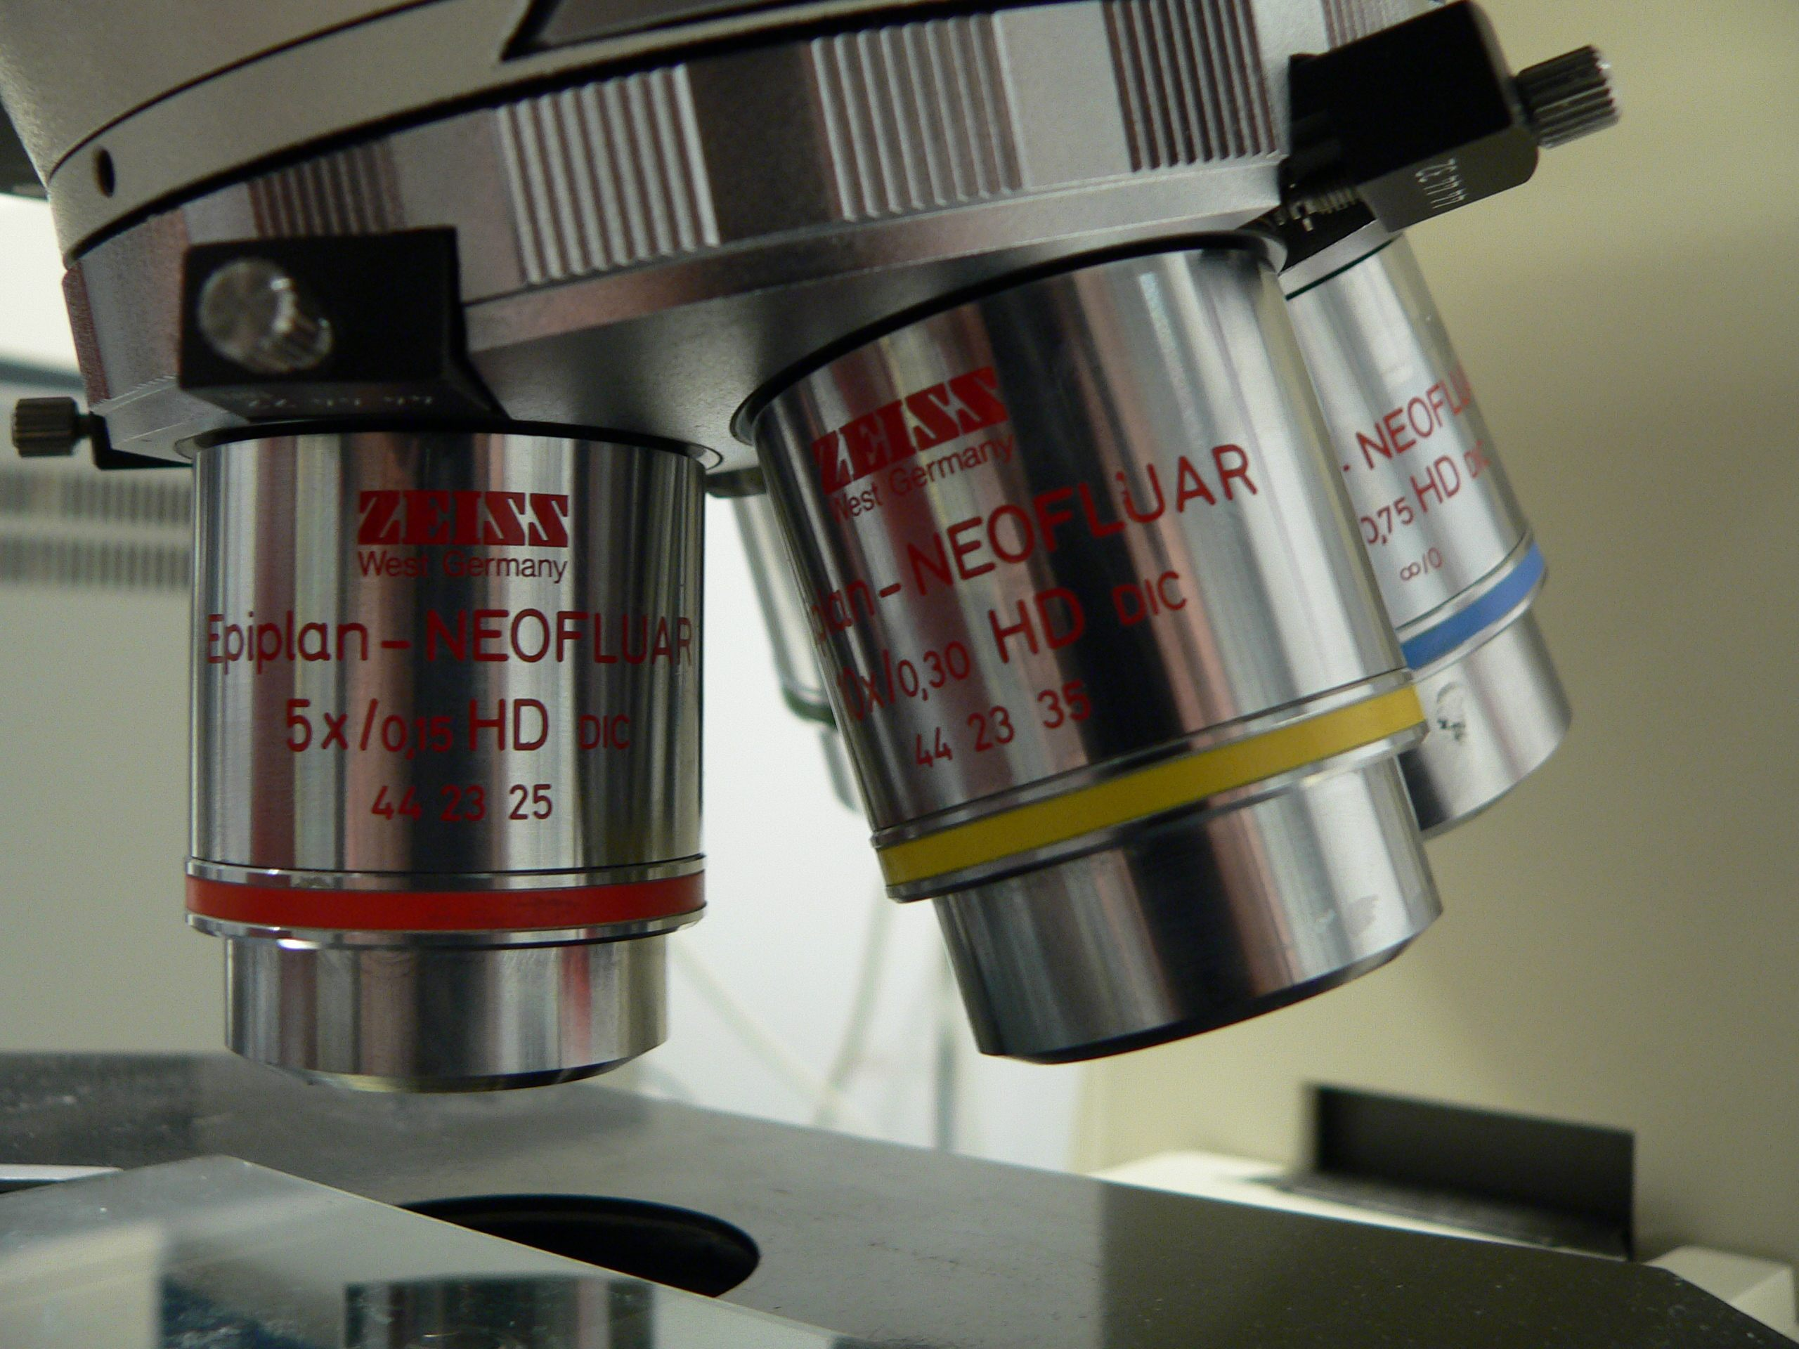
(Photo Credit: Rama, 2006, Wikimedia Commons)

a. 5x
b. 10x
*c. 50x
d. 100x
e. 500x

6. Reading the Vernier scale below, what is the measurement?
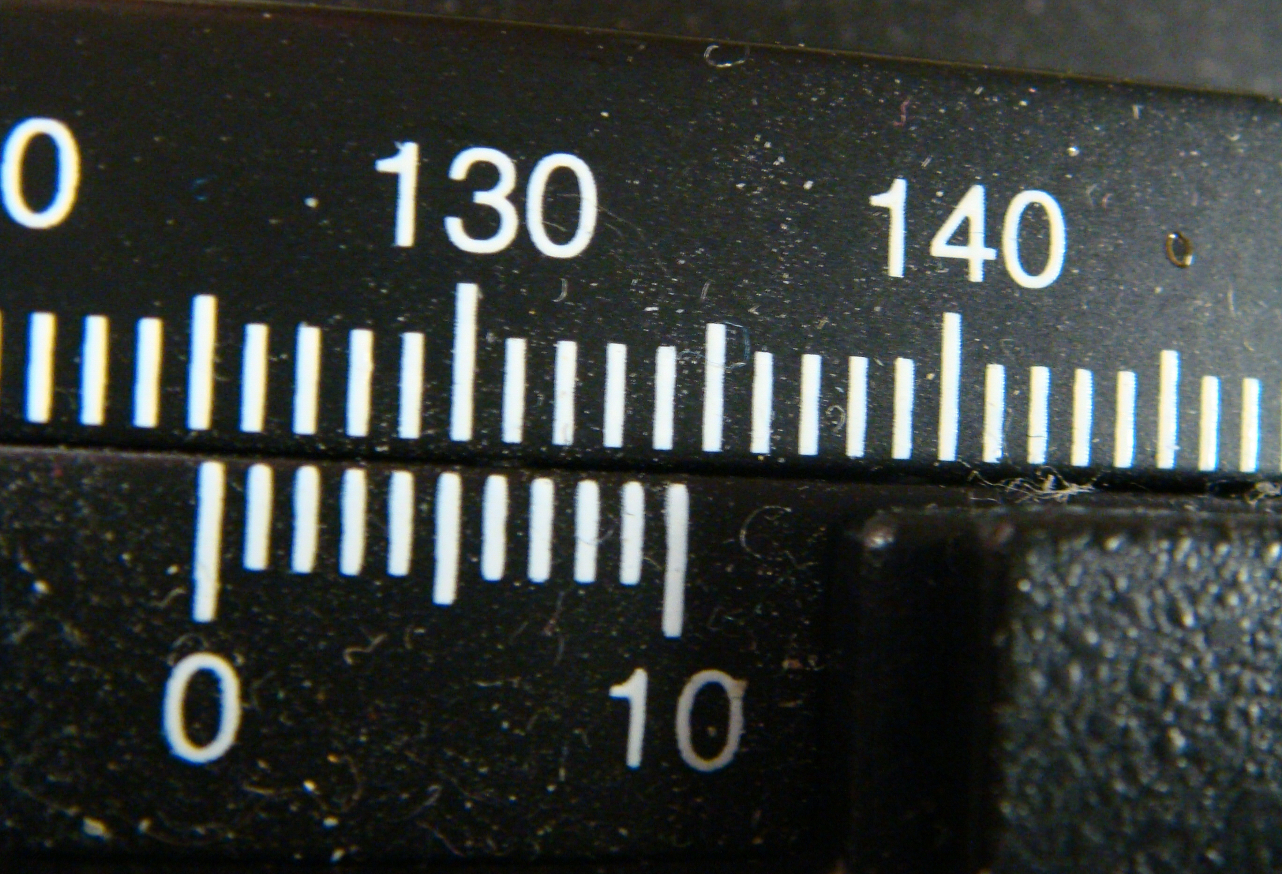

*a. 125.3
b. 126.4
c. 130.3
d. 131.4
e. 134.1

7. If you are using the dial calipers to measure an object, what is the correct
measurement?
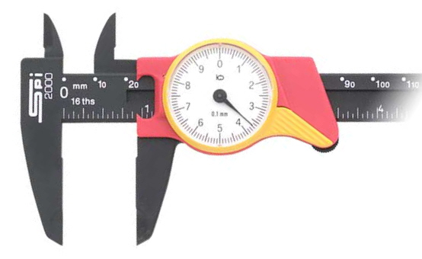

a. 1. 37 cm
b. 2.37 mm
*c. 2.37 cm
d. 20.37 cm

